Wiring and Connector Standards

GT Off-Road Racing | Data Acquisition

Ryan Chen

06/14/2021

Table of Contents

1.0 Overview 2

1.1 Introduction 2

1.2 Point of Contact 2

2.0 Wiring Standards 3

2.1 Connector genders between electrical components 3

2.2 Securing wires 3

3.0 Connector Pinout Standards 4

3.1 Introduction 4

3.2 XT30 4

Power 4

3.3 Micro-Fit 5

2-pin 5

3-pin 5

Analog Signal 5

Other 5

4-pin 5

I2C 5

Serial (RX/TX) 5

Other 6

6-pin 6

SPI 6

3.4 Weather-Pack 7

Power 7

4.0 References 8

5.0 Revision History 9

# 1.0 Overview

## 1.1 Introduction

# 2.0 Wiring Standards

## 2.1 Connector genders between electrical components

All connectors attached to an electrical component/system (PCB, battery, sensor, etc.) from components are male.

[Add analogy about islands and bridges]

All bridging cables/wires are female.

Figure 1: High-level overview of electrical wiring

## 2.2 Securing wires

Wires are secured to the car by zip ties. The zip ties typically go through mounting tabs on the car, but also go around the chassis frame.

# 3.0 Connector Pinout Standards

## 3.1 Introduction

A few key rules:

* If a custom color/pin pattern is used, include the connector diagram and pinout table in the relevant project’s documentation.

## 3.2 XT30

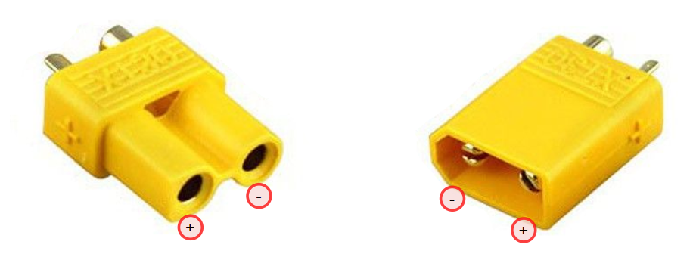

Figure 2: XT30 Connectors

#### Power

|  |  |  |
| --- | --- | --- |
| **Pin** | **Color** | **Description** |
| + | Red | Power |
| - | Black | Ground |

## 3.3 Micro-Fit

### 2-pin

### 3-pin

Figure 3: Micro-Fit 3-pin connector

|  |  |  |  |  |  |  |  |  |  |  |  |  |  |  |  |  |  |  |  |  |  |  |  |  |  |
| --- | --- | --- | --- | --- | --- | --- | --- | --- | --- | --- | --- | --- | --- | --- | --- | --- | --- | --- | --- | --- | --- | --- | --- | --- | --- |
| Analog Signal  |  |  |  | | --- | --- | --- | | **Pin** | **Color** | **Description** | | 1 | Red | Power | | 2 | White | Analog signal | | 3 | Black | Ground | | Digital Signal  |  |  |  | | --- | --- | --- | | **Pin** | **Color** | **Description** | | 1 | Red | Power | | 2 | White | Digital signal | | 3 | Black | Ground | |
| Other  |  |  |  | | --- | --- | --- | | **Pin** | **Color** | **Description** | | 1 | Red |  | | 2 | White |  | | 3 | Black |  | |  |

### 4-pin

Figure 4: Micro-Fit 4-pin connector

|  |  |  |  |  |  |  |  |  |  |  |  |  |  |  |  |  |  |  |  |  |  |  |  |  |  |  |  |  |  |  |  |
| --- | --- | --- | --- | --- | --- | --- | --- | --- | --- | --- | --- | --- | --- | --- | --- | --- | --- | --- | --- | --- | --- | --- | --- | --- | --- | --- | --- | --- | --- | --- | --- |
| I2C  |  |  |  | | --- | --- | --- | | **Pin** | **Color** | **Description** | | 1 | Red | Power | | 2 | Green | I2C Data (SDA) | | 3 | White | I2C Clock (SCL) | | 4 | Black | Ground | | Serial (RX/TX)  |  |  |  | | --- | --- | --- | | **Pin** | **Color** | **Description** | | 1 | Red | Power | | 2 | Green | RX | | 3 | White | TX | | 4 | Black | Ground | |
| Load Cell  |  |  |  | | --- | --- | --- | | **Pin** | **Color** | **Description** | | 1 | Red | Power | | 2 | Green | A+ | | 3 | White | A- | | 4 | Black | Ground | | Load Cell Signal  |  |  |  | | --- | --- | --- | | **Pin** | **Color** | **Description** | | 1 | Red | Power | | 2 | Green | VOUT | | 3 |  |  | | 4 | Black | Ground | |
| Other  |  |  |  | | --- | --- | --- | | **Pin** | **Color** | **Description** | | 1 |  |  | | 2 |  |  | | 3 |  |  | | 4 |  |  | |  |

### 6-pin

Figure 5: Micro-Fit 6-pin connector

|  |  |  |  |  |  |  |  |  |  |  |  |  |  |  |  |  |  |  |  |  |  |  |  |  |  |  |  |  |  |  |  |  |  |  |  |  |  |  |  |  |  |  |  |
| --- | --- | --- | --- | --- | --- | --- | --- | --- | --- | --- | --- | --- | --- | --- | --- | --- | --- | --- | --- | --- | --- | --- | --- | --- | --- | --- | --- | --- | --- | --- | --- | --- | --- | --- | --- | --- | --- | --- | --- | --- | --- | --- | --- |
| SPI  |  |  |  | | --- | --- | --- | | **Pin** | **Color** | **Description** | | 1 | Red | Power | | 2 | Green | MOSI/SDI | | 3 | Blue | MISO/SDO | | 4 | Orange | Serial clock (SCK) | | 5 | White | Chip select (CS) | | 6 | Black | Ground | | |  |  |  | | --- | --- | --- | | **Pin** | **Color** | **Description** | | 1 |  | Power | | 2 |  |  | | 3 |  |  | | 4 |  |  | | 5 |  |  | | 6 |  | Ground | |

## 3.4 Weather-Pack

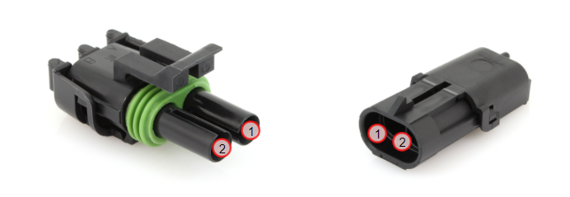

Figure 6: Weather-Pack 2-pin connector

#### Li-Po Batteries

|  |  |  |
| --- | --- | --- |
| **Pin** | **Color** | **Description** |
| 1 | Black | Ground |
| 2 | Red | Power |

# 4.0 References

# 5.0 Revision History

9/16/2021 (Ryan Chen) – Created high-level wiring standards for electrical systems/PCBs on the car. Inserted pictures of pins and empty tables of pinout diagrams for connectors.